DATA ANALYSIS FOR UNDERSTANDING THE IMPACT OF COVID–19 VACCINATIONS ON THE SOCIETY

In this paper author analysing vaccines dataset to forecast required vaccines compare to manufacturing or available vaccines and by using this forecasting manufacturers may increase and decrease their manufacturing quantity. This forecasting can impact society by taking decision on manufacturing vaccines and if in society more cases occurred then forecasting will be high and by seeing forecasting manufacturers may increase production.

Vaccines are manufacturing by multiple manufacturers such as JOHNSON AND JOHNSON, PFIZER and many more. In this forecasting will take all manufacturers and their production quantity as well as usage of vaccines and based on this Machine Learning algorithm called Decision Tree will forecast require vaccines for next 30 days

To implement this project we are using vaccines dataset to train decision tree algorithm and then this algorithm will predict require vaccines quantity for next 30 days. This dataset is saved inside ‘Dataset’ folder and below screen showing some records from dataset

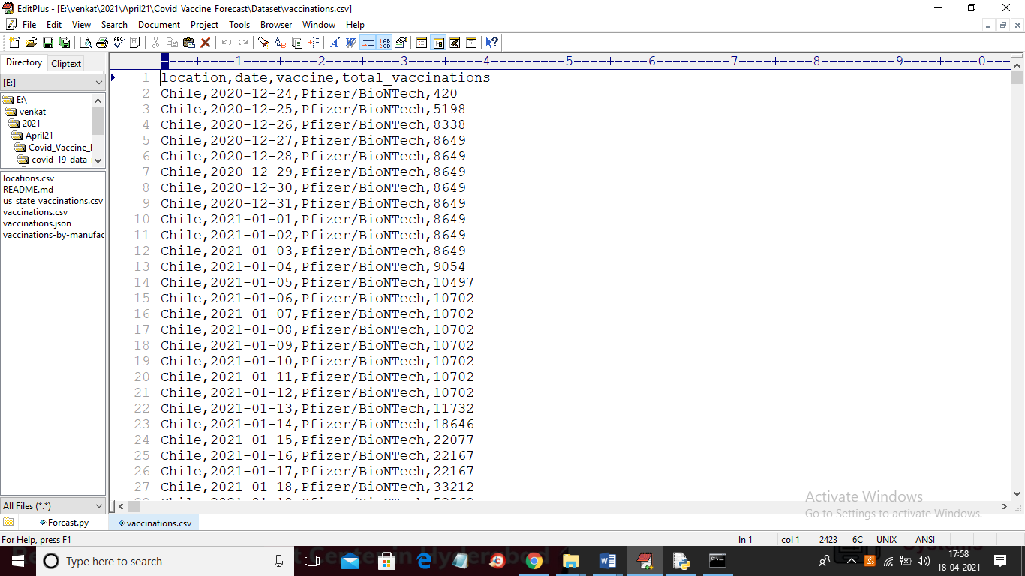

In above dataset first row contains dataset column names and other rows contains dataset values and in above dataset we have columns like location name, manufacturing date, vaccines and total vaccines manufacturing or using. We will use above dataset to train Decision Tree ML algorithm and perform forecasting

SCREEN SHOTS

To run project double click on ‘run.bat’ file to get below screen as this project working on data analysis so it will generate more graphs so I developed code as console based application

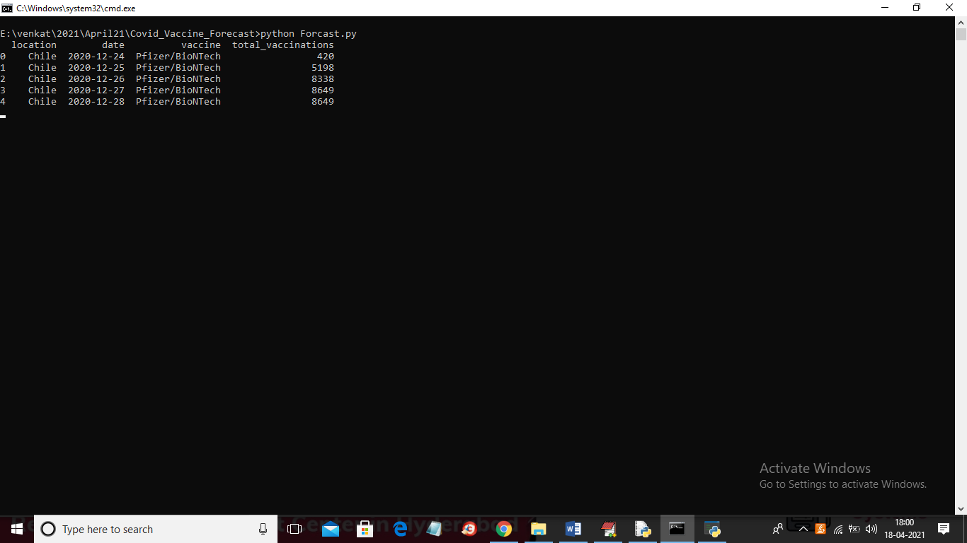

In above screen application starts accessing dataset and once it read all records then it will analyse all dataset to give below graph

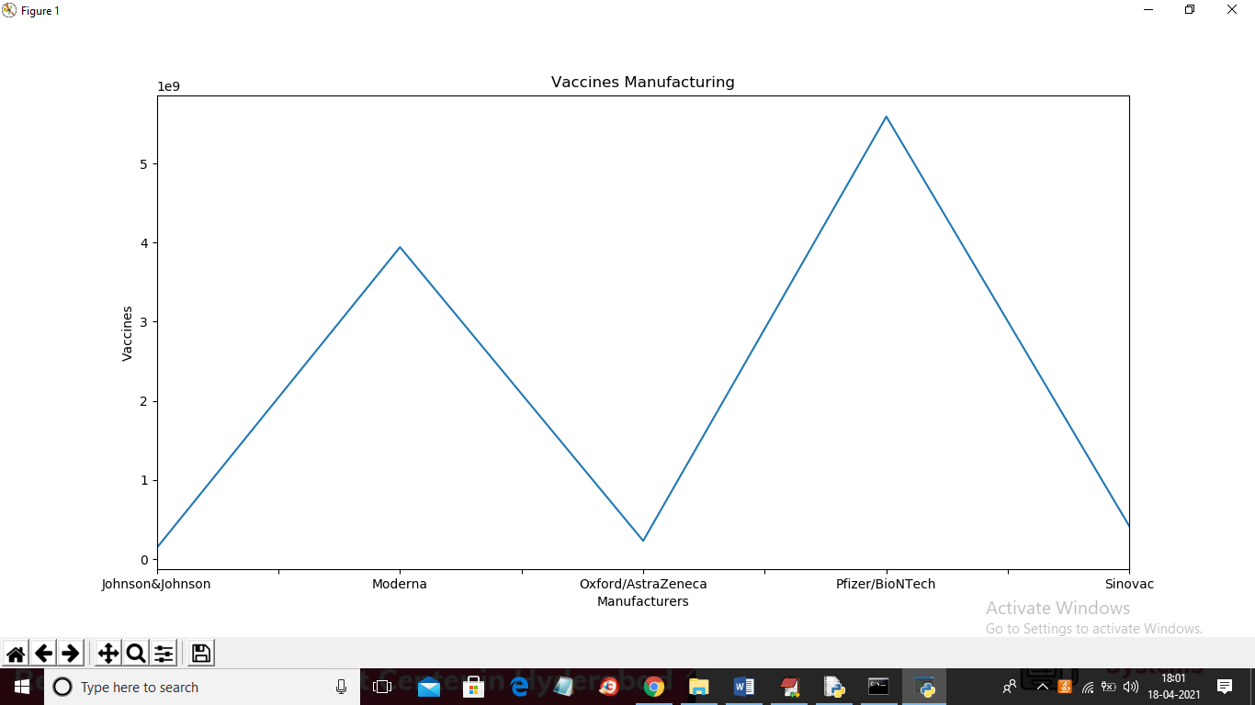

In above graph x-axis represents vaccine manufacturer companies and y-axis represents count of manufacturing vaccines. There is huge manufacturing so we will get count in power exponents and in top graph we can see 1e9 as total manufacturing quantity and now closed above graph to get below graph

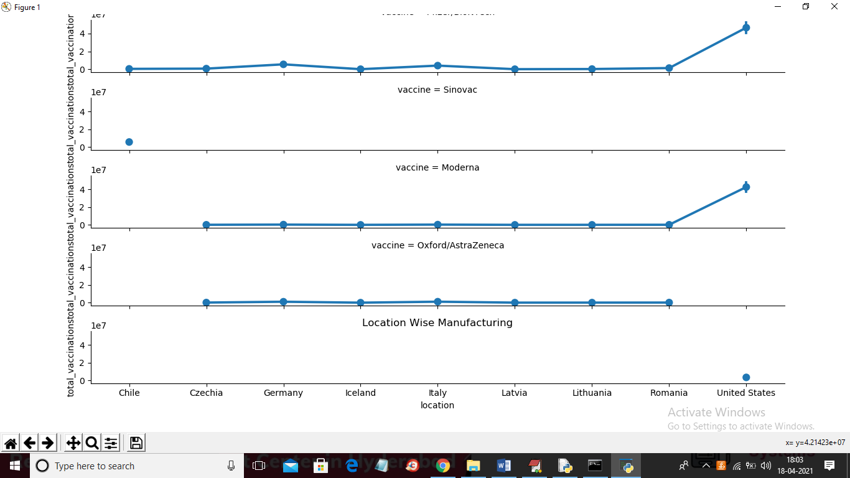

In above graph x-axis represents location/country names and y-axis represents vaccines manufacturing count for each country. In above graph each separate graph represents manufacturer making vaccines count for different countries. From above graph we can say that in UNITED STATES more vaccines are consuming and manufacturing. Now close above graph to get below forecasting result

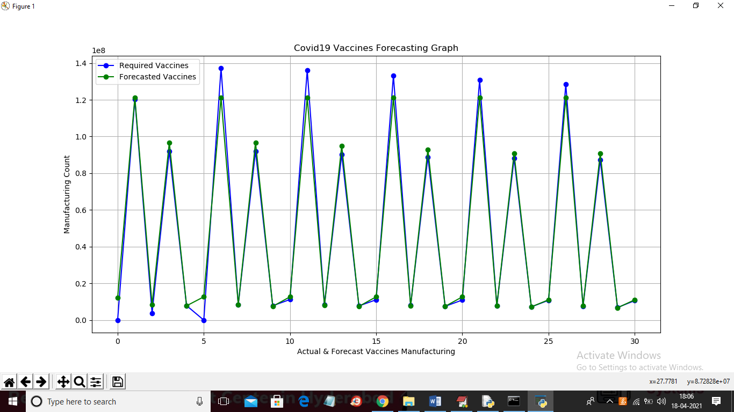

In above graph x-axis represents forecasting for next 30 days and y-axis represents required count. In above graph blue line represents required/manufacturing vaccines and green line represents forecasted vaccines. In above graph we can see there is close difference between require and forecasted vaccines so manufacture will go in normal way. If there is huge difference in require and forecast values then manufacturer will increase making count. This forecast will impact society in having sufficient vaccines on particular day or time. In above graph on 5th day more vaccines require and company will adjust making as per forecasting. In below console we can see real values of actual/require and forecast vaccines

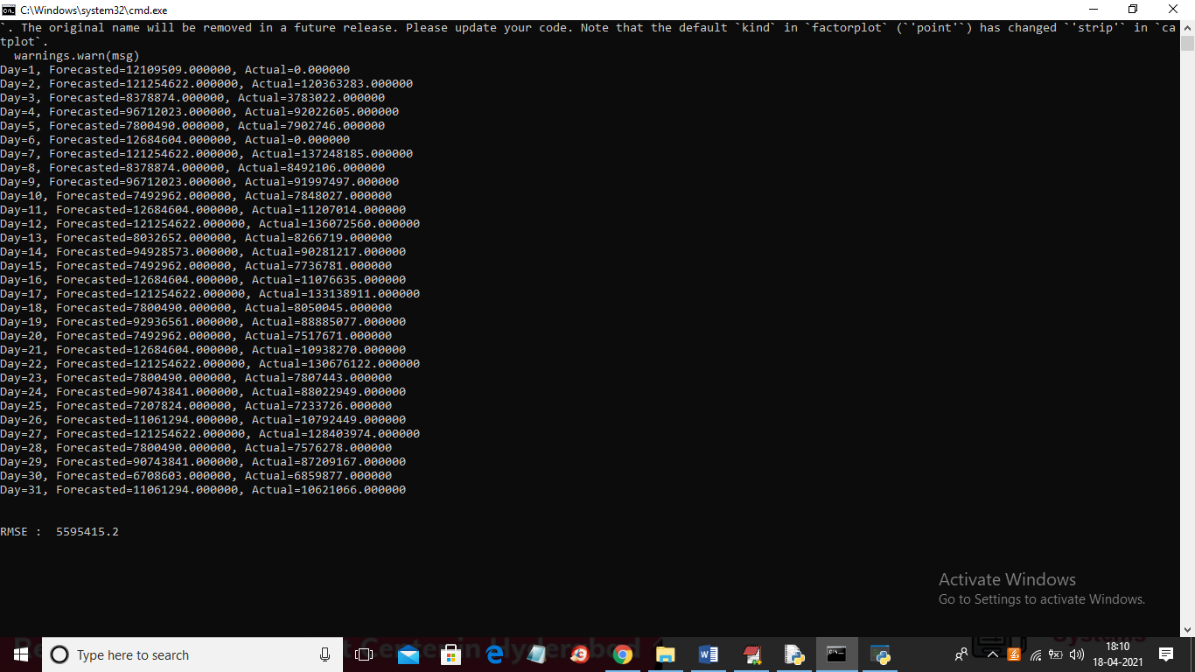

In above screen we can see actual/require and forecast vaccines for next 30 days. In above screen we can see little close difference between require and forecast vaccines.